Student ID Card Printing

Student ID Cards for Schools, Colleges, Universities & Educational Institutions
IDGen provides custom student ID card printing for educational institutions that need personalized identification cards for students.
From a small class batch to a large institution-wide requirement, IDGen can manage the identification workflow from student data and photographs to personalized card production and final dispatch.
Student ID cards can include:
- Student photograph
- Student name
- Admission / enrollment number
- Roll number
- Class / course
- Section
- Department
- Academic session
- Date of birth, where required
- Blood group, where required
- School / college / university name
- Institution logo
- QR code
- Barcode
- Contact information
- Other approved identification details
The exact information depends on the institution's requirements.
[Request Student ID Card Quote →]
[View ID Card Pricing →]

Student ID Card Printing for Every Type of Institution
The same student-ID workflow can be adapted to different educational environments.

Schools
For:
- Primary schools
- Secondary schools
- Senior secondary schools
- Private schools
- Public schools
- Residential schools
- Boarding schools

Colleges
For:
- Undergraduate students
- Postgraduate students
- Department-wise batches
- New admissions
- Annual renewals

Universities
For:
- Undergraduate students
- Postgraduate students
- Research scholars
- Department-wise identification
- Campus-wide student batches

Other Educational Institutions
Student identification can also be required by:
- Coaching institutes
- Training institutes
- Professional institutes
- Vocational institutions
- Educational organizations
One student ID card service can therefore support multiple educational environments without creating separate duplicate service pages.

What Can Be Printed on a Student ID Card?
A student ID card should contain the information required to identify the student clearly while avoiding unnecessary information.
A typical student card may contain:

Front
Institution Logo
Institution Name
Student Photograph
Student Name
Class / Course
Roll Number / ID Number

Back
Admission Number
Academic Session
Date of Birth, if required
Emergency / Contact Information, if required
QR Code / Barcode, if required
Institution Address
The final layout can be customized according to the institution's approved design.

Student ID Card Design
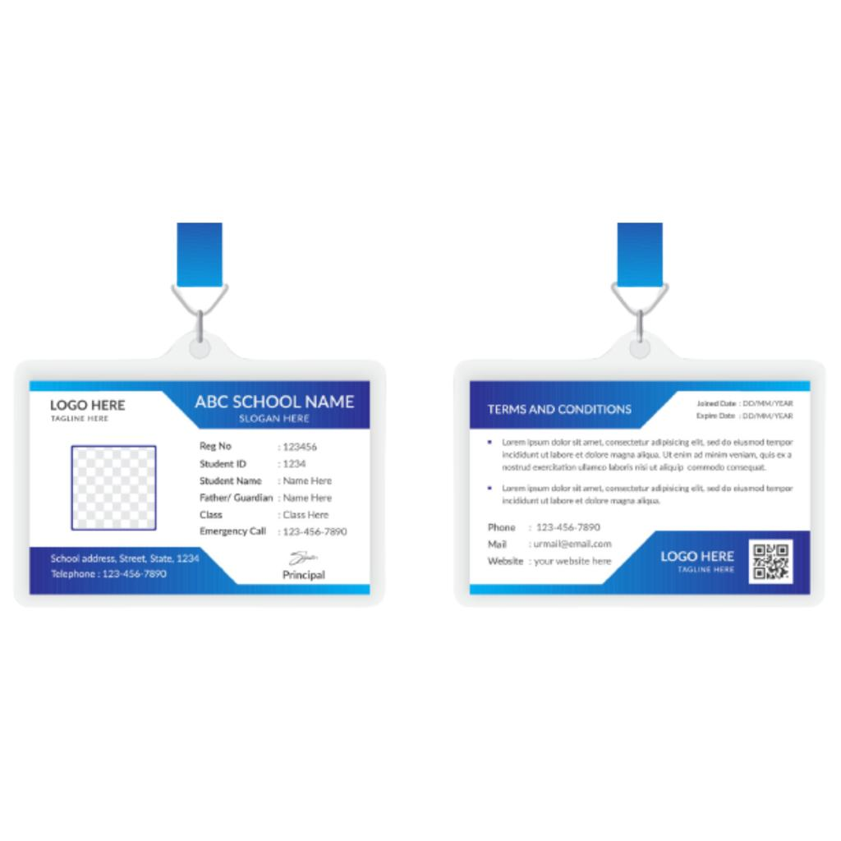
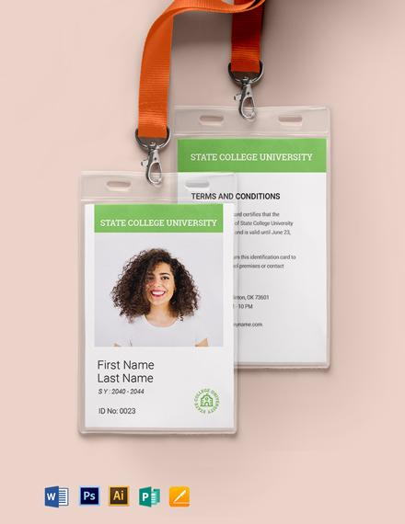
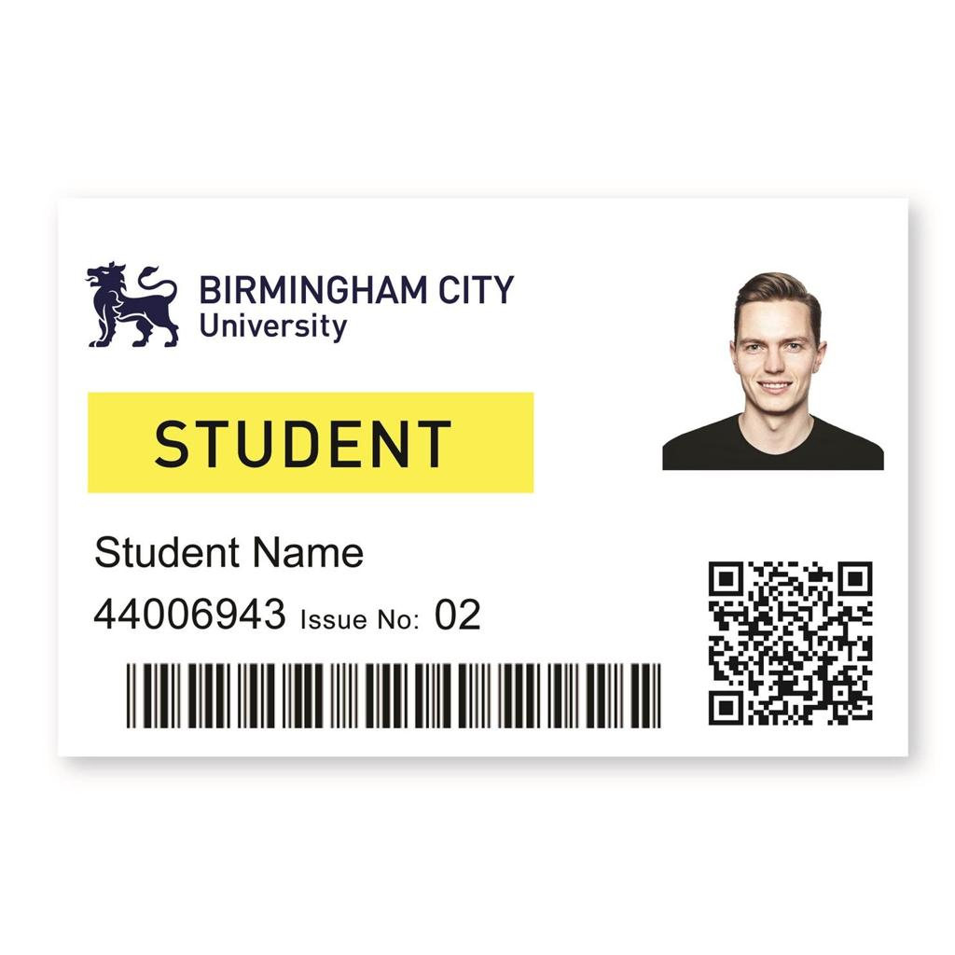
7
A student ID card can be designed around the institution's existing visual identity.
Customization can include:
- Institution logo
- Brand colours
- Typography
- Student photograph
- Academic information
- QR code
- Barcode
- Security elements
- Front and back layout
- Lanyard branding
Where an institution already has an approved design, the existing artwork can be used as the production reference.
Image file name:
student-id-card-printing-idgen.jpg
Alt text:
Custom student ID card printing for schools colleges and universities by IDGen

PVC Student ID Cards
IDGen provides personalized PVC ID cards for student identification requirements.
PVC cards are suitable for organizations that need a standardized card format for large batches of students.
The card specification can be selected according to the required application, design and production requirements.
For exact card specifications and current pricing, refer to the relevant product and pricing information rather than duplicating those details throughout this page.
[View ID Card Specifications & Pricing →]

Student ID Card Printing Process
A large student-ID project involves much more than printing names onto cards.
IDGen uses a structured workflow.

01 — Student Data
The institution provides the required student information.

02 — Photograph Collection
Student photographs are provided according to the agreed data format.

03 — Data Preparation
The information is organized for personalization and production.

04 — Design
The student card design is prepared using the approved institution requirements.

05 — Preview
The institution can review the personalized card information where applicable.

06 — Approval
The approved design and data are confirmed before production.

07 — Printing
The student cards move into production.

08 — Quality Check
Finished cards are checked against the applicable requirements.

09 — Accessories
Where required, cards can be combined with:
Holder + Hook + Custom Printed Lanyard

10 — Dispatch
The completed order is packaged and dispatched according to the applicable order timeline.

Student ID Card + Complete Identification Set
An institution may need more than just the PVC card.
IDGen allows student identification to be configured according to the actual requirement.

Card Only
Student ID Card
For institutions that already have accessories.

Card + Holder
Student ID Card + Holder
For protected card storage.

Wearable Student ID
Student ID Card + Holder + Hook + Custom Printed Lanyard
For students who need to wear their ID card.

Complete Student ID Setup
Student ID Card + Ultrasonic Sealing + Holder + Hook + Custom Printed Lanyard
The appropriate configuration depends on the institution's card and attachment requirements.
[Explore Complete ID Card Setup →]

Custom Student ID Lanyards
Educational institutions can also customize their lanyards with:
- Institution logo
- Institution name
- School / college branding
- Brand colours
- Academic session
- Repeating artwork
A typical student identification setup can therefore be:
Student ID Card → Holder → Hook → Custom Printed Lanyard
The lanyard can be supplied separately or coordinated as part of the overall student identification requirement.
[Explore Custom Printed Lanyard Printing →]

Student ID Card Data Collection
For institutions with hundreds or thousands of students, collecting photographs and information can become one of the most time-consuming parts of the project.
IDGen Studio is designed to help organize this stage.

Digital Workflow
Student Registration → Data Collection → Photograph → Preview → Approval → Printing
Depending on the project, the workflow can help organizations organize:
- Student names
- Admission numbers
- Roll numbers
- Classes
- Sections
- Courses
- Departments
- Academic sessions
- Photographs
- Other required information
This creates a connection between the student information and the final personalized ID card.
[Explore IDGen Studio →]

Bulk Student ID Card Printing
Student ID card requirements are commonly bulk projects.
A single institution may require cards for:
- New admissions
- Existing students
- Multiple classes
- Multiple departments
- Multiple campuses
- Annual ID renewal
- Replacement cards
IDGen supports bulk personalized ID card projects, with the actual production schedule depending on:
- Number of students
- Data readiness
- Photograph readiness
- Design approval
- Card specification
- Accessories
- Assembly requirements
- Quality-control requirements
For large requirements, the most important factor is not only printing capacity but data readiness and approval speed.
[Explore Bulk ID Card Printing →]

Student ID Cards for New Academic Sessions
Many institutions produce new ID cards at the beginning of an academic session.
A typical annual workflow can be:
Student Admission → Data Collection → Photograph Collection → Card Design → Preview → Approval → Bulk Printing → Distribution
IDGen can support this workflow for new student batches and renewal projects.
Institutions can also maintain a standardized design so that future academic batches can be produced using the same identification system with updated student information.

Replacement Student ID Cards
Student cards may sometimes need replacement because of:
- Lost cards
- Damaged cards
- Incorrect information
- Photograph changes
- Course changes
- Class changes
- Other institutional requirements
Replacement requirements can be handled according to the institution's supplied data and production specifications.
For replacement orders, providing the correct student information and approved design reference helps reduce avoidable errors.

Student ID Cards With QR Code or Barcode
Institutions may choose to include a QR code or barcode on student cards.
Possible applications include:
- Student identification
- Record lookup
- Library systems
- Attendance systems
- Verification workflows
- Internal institutional systems
The QR code or barcode should be generated according to the institution's required data or system specifications.
For RFID requirements, use the dedicated RFID service rather than treating RFID as a standard printed-card feature.
[Explore RFID Card Printing →]

Student ID Card Security & Accuracy
A student ID card is a personalized identification document.
For large batches, accuracy is particularly important because even a small data error can affect an individual student's card.
IDGen's workflow therefore emphasizes:
Data → Design → Preview → Approval → Production → Quality Check
This helps provide an opportunity to identify errors before bulk production where applicable.

Student ID Card Applications
Student identification cards can be used for:
- Campus identification
- Student verification
- Library access
- Examination identification
- Institutional events
- Laboratory access
- Hostel identification
- Transportation identification
- Internal student services
- General campus identification
The actual use depends on the institution's policies and systems.

Student ID Card Printing in Assam & Northeast India
IDGen is based in Guwahati, Assam and serves educational organizations across Assam and the wider Northeast India market.
Student ID card requirements can be supported for institutions in locations including:
- Guwahati
- Jorhat
- Dibrugarh
- Silchar
- Tezpur
- Nagaon
- Tinsukia
- Sivasagar
- Golaghat
- Bongaigaon
- Diphu
- North Lakhimpur
- Barpeta
For location-specific information, use the relevant service-area pages.
[Student ID Card Printing in Assam →]
[Student ID Card Printing in Guwahati →]

Why Choose IDGen for Student ID Cards?
We should not repeat the entire Why IDGen page here.
Instead, this page should give only the student-specific reasons:

Student-Focused Workflow
Designed around student data, photographs and personalized card production.

Bulk Requirements
Suitable for large student batches and institutional requirements.

Preview Before Production
Where applicable, student information can be reviewed before production.

Complete Identification
Cards can be combined with holders, hooks and custom printed lanyards.

Digital Data Workflow
IDGen Studio can support student data and photograph collection.

One Identification Partner
Institutions can coordinate cards and required accessories through one identity-focused supplier.
For the broader company story, manufacturing capability and quality philosophy:
[Why Choose IDGen →]

Student ID Card Pricing
Rather than repeating a large pricing table here, keep this page focused on student ID card service intent.
The current pricing should live on the central pricing architecture.

Need the Current Price?
[View Student / ID Card Pricing →]
Pricing may depend on:
- Quantity
- Card specification
- Printing requirement
- Data/personalization
- Accessories
- Lanyard
- Holder
- Hook
- Sealing
- Delivery requirements
This keeps pricing centralized and prevents conflicting prices across multiple pages.

Who Can Order Student ID Cards?
Student ID card printing can be used by:
- Schools
- Colleges
- Universities
- Coaching institutes
- Training institutes
- Vocational institutes
- Professional institutes
- Educational organizations
- Hostels and residential institutions
- Other student-based organizations
The important SEO point is that school, college and university are covered naturally inside one authoritative student-ID service page, instead of creating multiple pages with nearly identical content.

Frequently Asked Questions

What is a student ID card?
A student ID card is a personalized identification card issued by an educational institution to identify a student and provide required institutional information.

Can IDGen print student ID cards for schools?
Yes. IDGen provides customized student ID card printing for schools and other educational institutions.

Can colleges order student ID cards?
Yes. The same student ID card printing service can be used for college students, including department-wise and batch-wise requirements.

Does IDGen print university student ID cards?
Yes. University student identification projects can include undergraduate, postgraduate and research-student cards according to the institution's requirements.

Can student ID cards include photographs?
Yes. Student photographs can be personalized onto the cards according to the supplied data and approved design.

Can student ID cards include QR codes?
Yes. QR codes or barcodes can be incorporated when required and when the required data is provided.

Can student ID cards include lanyards?
Yes. Student cards can be supplied with suitable holders, hooks and custom printed lanyards.

Can I order student ID cards in bulk?
Yes. Bulk student ID card projects can be handled according to quantity, data readiness, specifications and production requirements.

Can IDGen collect student data?
Yes. IDGen Studio is designed to support digital information and photograph collection for suitable projects.

Can I see the card before printing?
Where applicable, the workflow can include a preview and approval stage before production.

Can student ID cards be replaced?
Yes. Replacement cards can be produced according to the supplied student information and approved requirements.

Quick Answer — Student ID Card Printing
IDGen provides customized student ID card printing for schools, colleges, universities, coaching institutes and other educational organizations. Student cards can include photographs, names, roll numbers, admission numbers, classes, courses, departments, academic sessions, QR codes and other required information. Bulk orders can also be combined with holders, hooks, custom printed lanyards and suitable ultrasonic-sealing configurations.

Start Your Student ID Card Project
You don't need to prepare the entire project before contacting us.
Send us:
Approximate Quantity + Institution Type + Existing Design (if available) + Student Data Format + Required Accessories
IDGen can then help determine the appropriate production configuration.
[Request Student ID Card Quote →]
[View Pricing →]
[Explore IDGen Studio →]
[Contact IDGen →]

SEO Metadata

SEO Title
Student ID Card Printing | School, College & University ID Cards | IDGen

Meta Description
Custom student ID card printing for schools, colleges, universities and educational institutions. Bulk PVC student cards with photo, QR code, lanyard, holder and complete ID solutions.

URL
/student-id-card-printing/

Primary Keyword
student ID card printing

Secondary Keywords
- student ID card
- student ID card printing
- student identity card printing
- student ID card manufacturer
- student ID card supplier
- PVC student ID card
- school student ID card
- college student ID card
- university student ID card
- student ID card printing service
- bulk student ID card printing
- student ID card printing company

GEO Keywords
Use naturally:
- student ID card printing Assam
- student ID card printing Guwahati
- student ID card supplier Assam
- student ID card printing Northeast India
- school student ID card printing Assam
- college student ID card printing Guwahati

AEO — Direct Answers

Who provides student ID card printing in Guwahati?
IDGen provides customized student ID card printing from Guwahati, Assam, serving educational organizations across Assam and the wider Northeast India market.

Can student ID cards be printed in bulk?
Yes. IDGen supports bulk personalized student ID card projects for educational institutions, with production requirements depending on quantity, data readiness, specifications and approval.

What information can be printed on a student ID card?
Student ID cards can include the student's name, photograph, roll number, admission number, class or course, department, academic session, QR code, barcode and other institution-approved information.

Can schools and colleges order student ID cards from the same supplier?
Yes. IDGen's student ID card printing service is designed to serve schools, colleges, universities and other educational institutions through the same core workflow.

Can student ID cards come with lanyards?
Yes. Student ID cards can be combined with suitable holders, hooks and custom printed lanyards according to the institution's requirements.

Internal Linking — Keep It Clean
This page should not repeat detailed explanations from other pages.
Topic | Link to
General ID card service | /id-card-printing/
Pricing | /pricing/
Lanyards | /custom-printed-lanyard-printing/
RFID | /rfid-card-printing/
Ultrasonic sealing | /ultrasonic-sealing/
Holders | /id-card-holders/
Hooks | /id-card-hooks/
Digital data collection | /idgen-studio/
Company trust/capability | /why-idgen/
Assam service | /service-areas/assam/
Guwahati service | /service-areas/assam/guwahati/
Quote | /request-a-quote/

Important
Don't create:
- /school-id-card-printing/
- /college-id-card-printing/
- /university-id-card-printing/
as separate SEO pages.
Instead:
/student-id-card-printing/
owns the whole topic, while school, college and university are important subsections/entities within it.
That gives Google and AI systems a much clearer entity relationship:
IDGen → Student ID Card Printing → Educational Institutions → Schools / Colleges / Universities → Student Identification

Images to Add
I recommend 4–5 original images, not 15–20 stock images.
Image | File name | ALT text
Hero | student-id-card-printing-idgen-guwahati.jpg | Student ID card printing by IDGen in Guwahati
Student cards | custom-student-id-cards-pvc.jpg | Custom PVC student ID cards for educational institutions
Complete set | student-id-card-lanyard-holder-set.jpg | Student ID card with holder hook and custom lanyard
Data workflow | student-id-card-data-collection-idgen-studio.jpg | Student ID card data collection and preview workflow
Bulk production | bulk-student-id-card-printing-idgen.jpg | Bulk student ID card printing for schools colleges and universities
Don't keyword-stuff ALT text. Each alt should describe the actual image.

Video opportunity
Add one short original video around the middle of the page:
“How IDGen Processes a Bulk Student ID Card Order”
Suggested sequence:
Student Data → Photo Collection → Design → Preview → Approval → Printing → Quality Check → Finished Cards
This is much more valuable for trust and AEO than a generic promotional video.

Hero image recommendation
Use a real IDGen-produced student-card image rather than a generic stock photograph. Ideally show:
multiple finished student cards + one lanyard/holder setup + clean production-ready presentation
Avoid showing machinery unless the image specifically supports a manufacturing claim.

One important SEO decision for this page
Notice what I deliberately didn't do:
I did not copy the full /why-idgen/ content, full lanyard explanation, full ultrasonic-sealing explanation, full pricing table, or full manufacturing explanation.
Instead, this page answers the student's/institution's buying questions and links to the authoritative page for deeper information.
That is the architecture we should use for every remaining IDGen page: one primary search intent per page + relevant solutions + concise supporting information + strong internal links, rather than trying to make every page contain the entire website.

